User

Manual

Dashboard

**Version 6.1**

|  |  |
| --- | --- |
| ***Corporate Office*** | ***Offshore Development Center*** |
| *1 Pickering Street*  *#06-03 Great Eastern Centre*  *Singapore 048659* | *Plot # 122 & 123, N.S.E.Z, Phase -2*  *NOIDA, UP 201 305*  *India*  *Tel: 91.11.91.2510483* |

|  |  |  |  |  |
| --- | --- | --- | --- | --- |
| **Author** | | | | |
| **Name** | **Role** | **Date of Preparation** | **Signature** | |
| Varun Gupta | Business Analyst | 30-Jan-2015 | Varun | |
| **Reviewer(s)** | | | | |
| **Name** | **Role** | **Date of Review** | **Signature** | |
| Pravesh Kumar | Manager Projects |  |  | |
|  |  |  |  | |
| **Approver** | | | | |
| **Name** | **Role** | **Date of Approval** | **Signature** | |
| ChengChoon Yip | VP Ebix Exchange  Asia |  |  | |
| **Document Path** | **Version Number** | **Date of Release** | | |
|  | 2.4 | 5 March 2015 | | |
|  | 4.0 | 31st March 2015 | | |
|  | 5.0 | 1 April 2015 | | |
|  | 5.1 | 15 April 2015 | | |
|  | 5.2 | 11 May 2015 | | |
|  | 6.0 |  | | |
|  | 6.1 | 8 July 2015 | | |
| **Revision History** | | | | |
| **Version Number** | **Date of Release** | **Section/ Page # Changed** | | **Details of Changes** |
| 1.0 | 5 March 2015 | Created document for system admin module | | Whole document Created |
| 4.0 | 31st March 2015 | 23 / 115 | | Added upload module |
| 5.0 | 1 April 2015 | Whole document | | Changed sequence of Menus as per actual system admin master sequence. |
| 5.1 | 15 April 2015 | 5.1.4 Select Permission List Screen | | Updated as per latest requirement of security management |
| 5.2 | 11 May 2015 | Section 12, 13 and 28 | | FAL, Common master manual and LOG Request module’s user manual added |
| 6.0 |  | Section 1 | | Removed all sections and added Dashboard section |
| 6.1 | 8 July 2015 | Entire document | | Edited sentences throughout the document |

|  |  |  |
| --- | --- | --- |
| **References** | | |
| **Document** | **Date Received** | **Author** |
|  |  |  |

Contents

1 Dashboard 4

1.1 Task section functionality 6

# Dashboard

* After login, the Dashboard screen is the default view for the User. Clicking on the Home button will also bring the User back to the Dashboard screen.
* Dashboard Screen will be used for viewing records related to all claims for particular selected section from the drop down list.
* Sorting can be performed on all columns of Dashboard sections.
* User can click on header of column to view list in increasing or decreasing order.

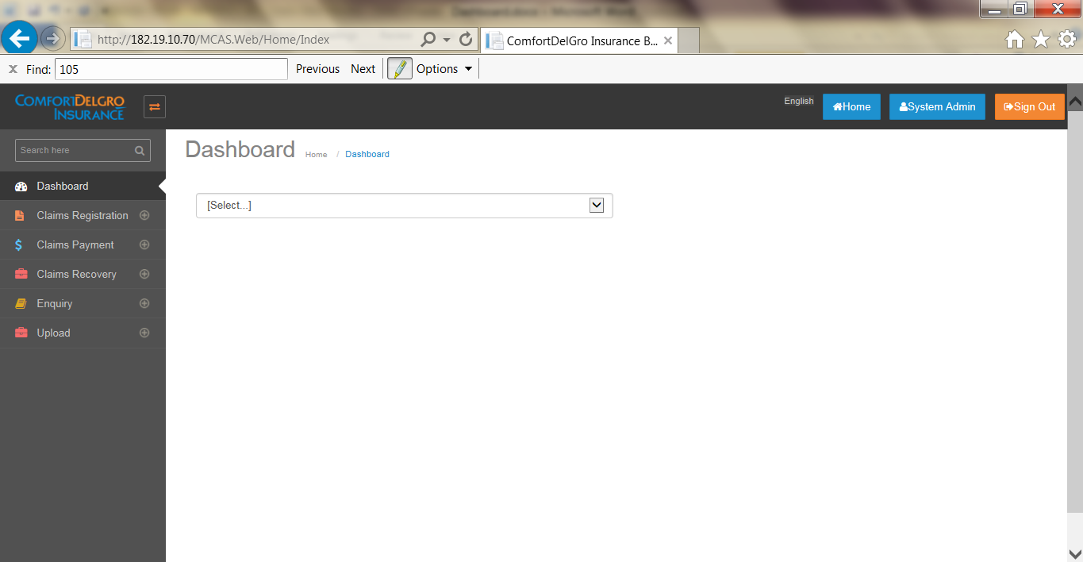

* On the Dashboard screen, User can select below mentioned transactions for which he/she wants to view records.
  + Diary
  + Tasks
  + Mandate
  + Payment

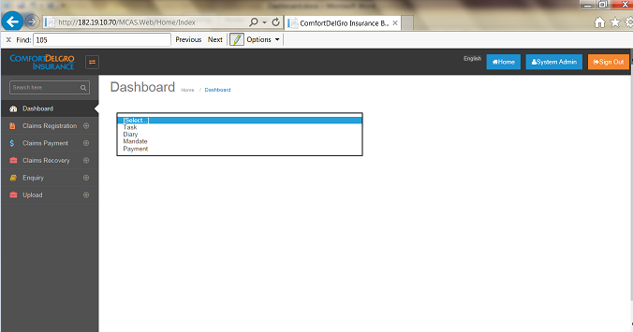

## Task section functionality

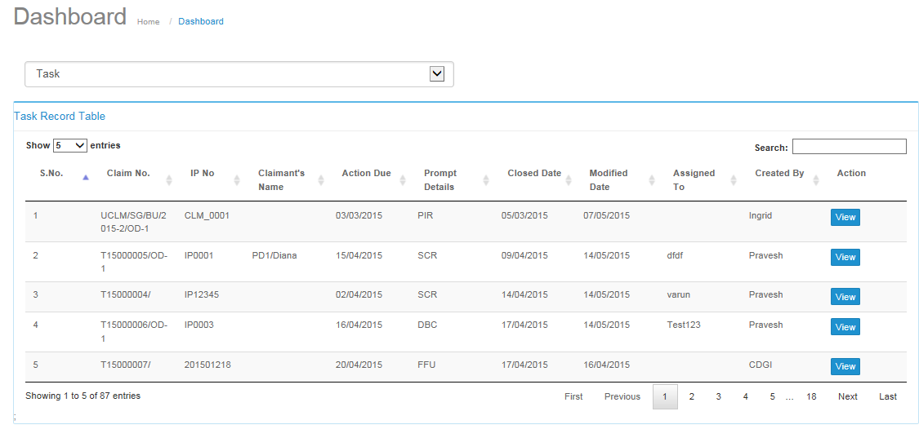

* Clicking on View Button will bring user the task screen.
* User can view Task records corresponding to all existing claims.

### Task screen after clicking on the task section

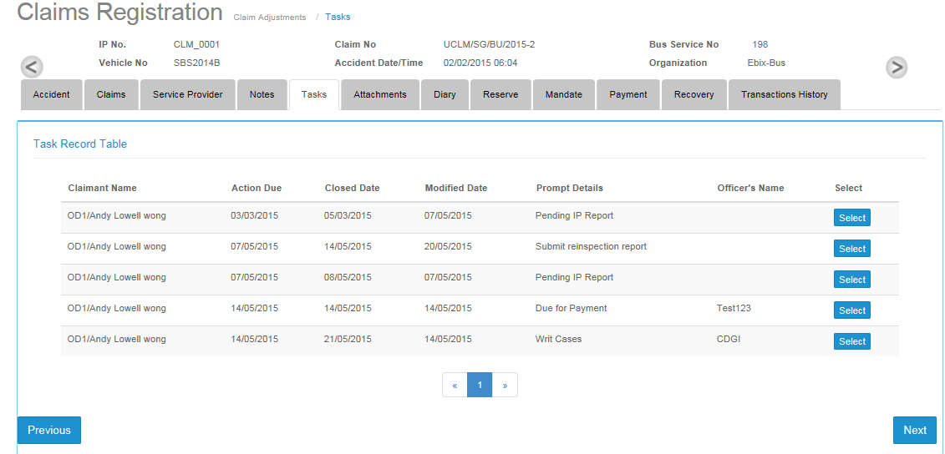

## Diary Section Functionality

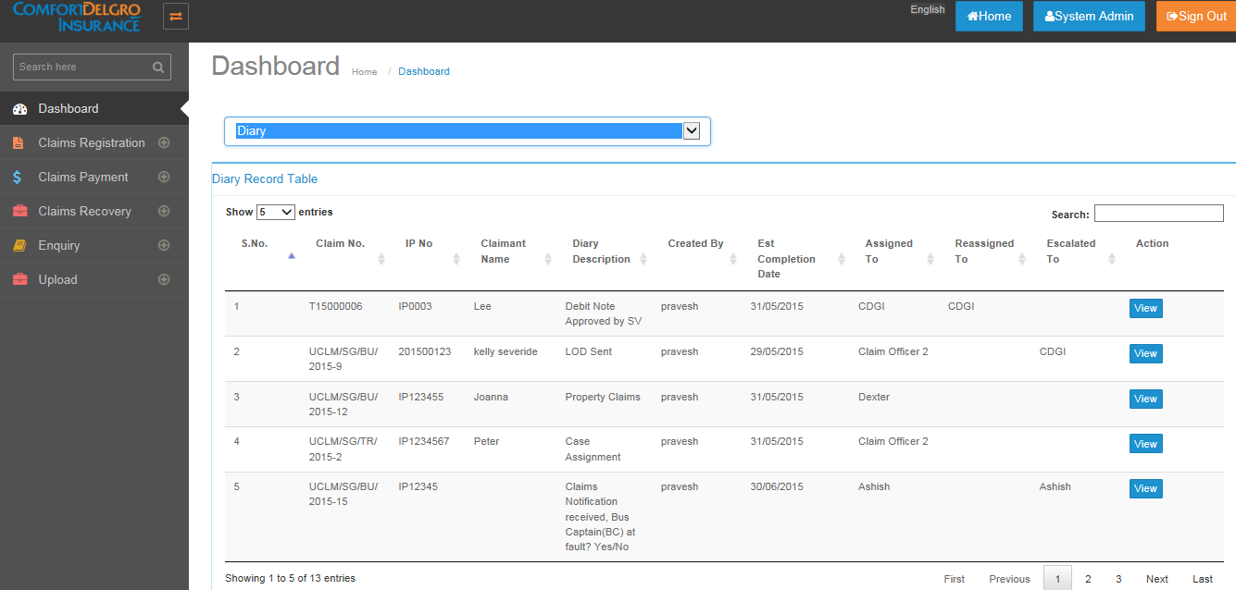

* User can directly go to particular diary tab screen by clicking on view button.
* Dairy can be reassigned by clicking on reassigned button which appears below the view button. (Note: Reassign button will appear: if logged in user is original user or has special permission).

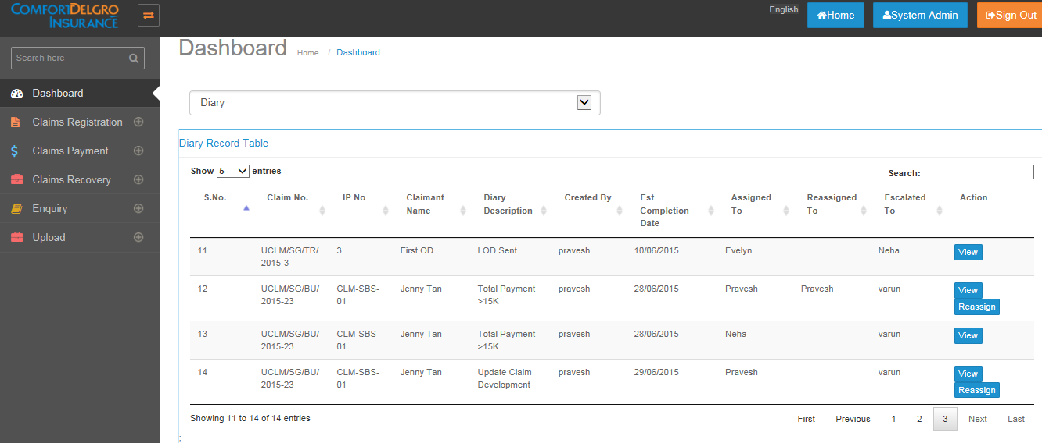

* User will see below screen for related diary, after clicking on the reassign button.

### Diary screen after clicking on the view/reassign button

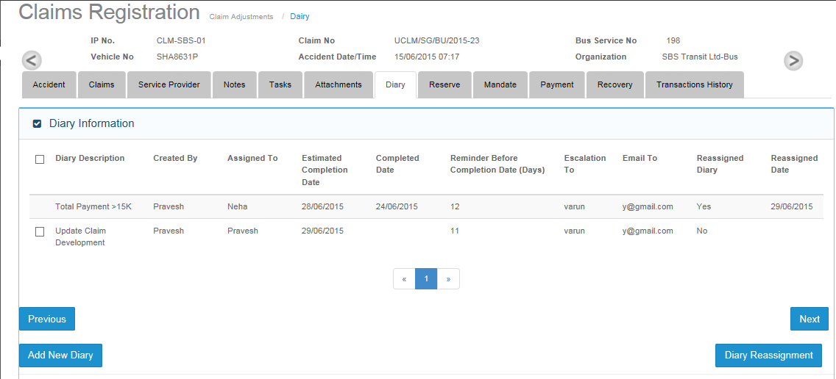

## Mandate Screen section

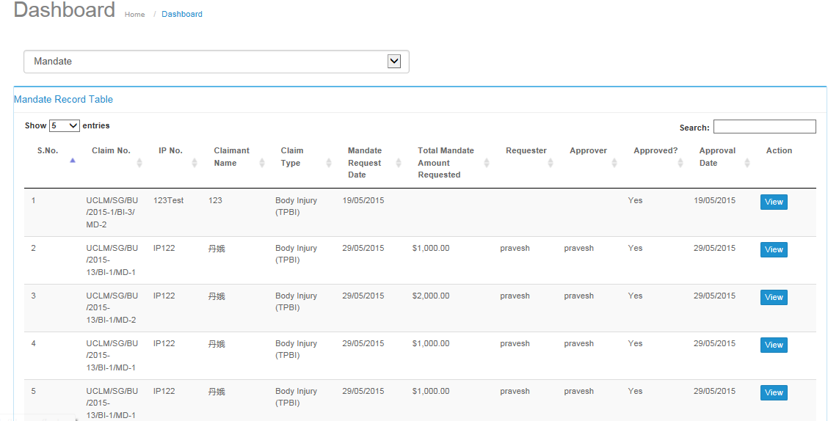

* All pending requests and approved mandates will be shown when user selects “Mandate” from the list.
* Upon clicking on the View button, user will be navigated to the mandate screen on claim adjustment menu.

### Mandate Screen after clicking on the mandate section

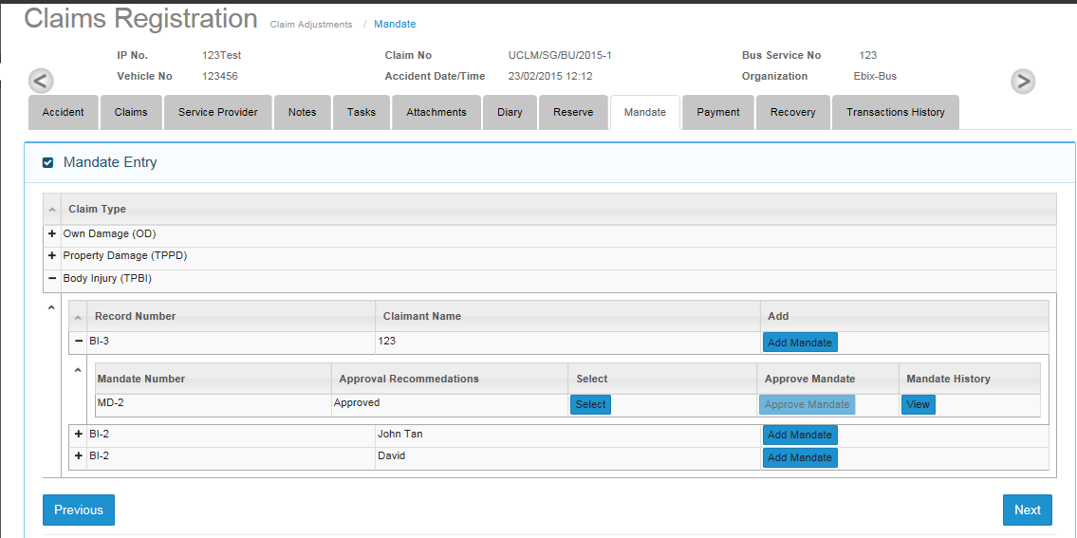

## Payment section

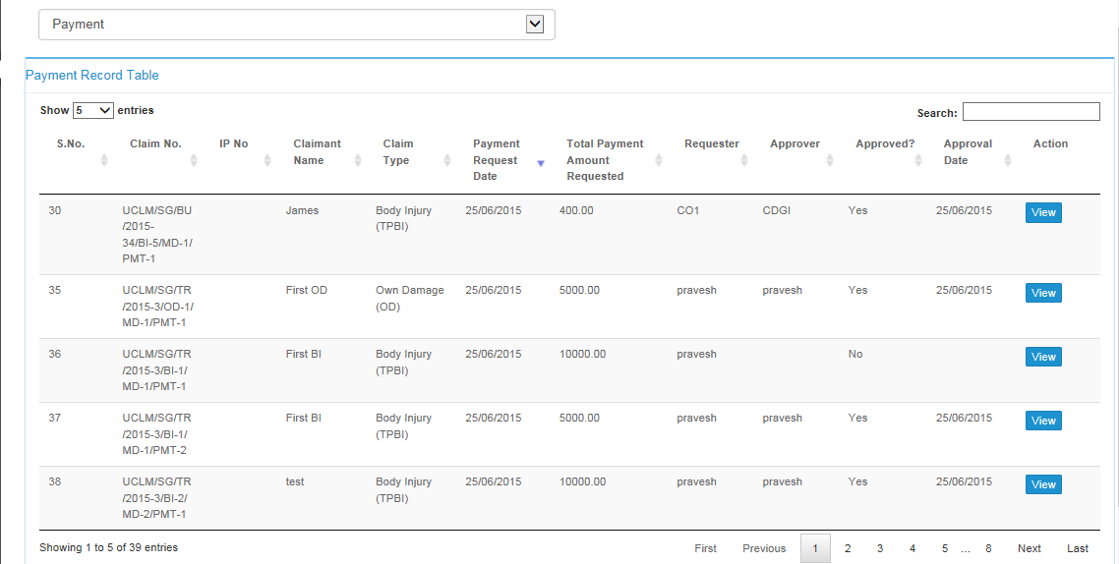

* All pending requests and approved payment entries will be shown when user selects “Payment” from the list.
* By clicking on the View button, user will be navigated to the Payment screen from claim payment processing menu.

### Payment screen after clicking on the payment record

